Form controls

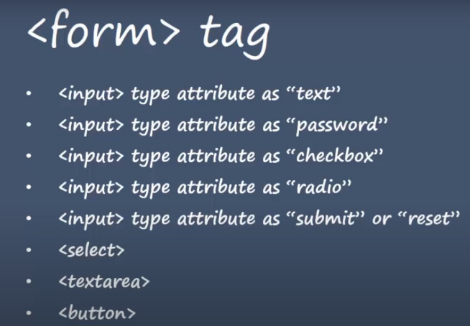

---------------------------------------------------------------------------------------------

<form action="/action_page.php">

**The Action Attribute**

The action attribute defines the action to be performed when the form is submitted.

Usually, the form data is sent to a file on the server when the user clicks on the submit button.

In the example below, the form data is sent to a file called "action_page.php". This file contains a server-side script that handles the form data:

-----------------------------------------------------------------------------------------------------------------

form action="/action_page.php" target="_blank">

## The Target Attribute

The target attribute specifies where to display the response that is received after submitting the form.

The target attribute can have one of the following values:

|  |  |
| --- | --- |
| **Value** | **Description** |
| _blank | The response is displayed in a new window or tab |
| _self | The response is displayed in the current window |
| _parent | The response is displayed in the parent frame |
| _top | The response is displayed in the full body of the window |
| *framename* | The response is displayed in a named iframe |

The default value is _self which means that the response will open in the current window.

----------------------------------------------------------------------------------------------------------------------

<form action="/action_page.php" method="get">

The form-data can be sent as URL variables (with method="get") or as HTTP post transaction (with method="post").

The default HTTP method when submitting form data is GET.

**Notes on GET:**

* Appends the form data to the URL, in name/value pairs
* NEVER use GET to send sensitive data! (the submitted form data is visible in the URL!)
* The length of a URL is limited (2048 characters)
* GET is good for non-secure data

**Notes on POST:**

* Appends the form data inside the body of the HTTP request (the submitted form data is not shown in the URL)
* POST has no size limitations, and can be used to send large amounts of data.

-------------------------------------------------------------------------------------------------------------------

# **HTML Form Elements**

## The <input> Element

One of the most used form element is the <input> element.

The <input> element can be displayed in several ways, depending on the type attribute.

Given below:

|  |  |
| --- | --- |
| <input type="button">  <input type="checkbox">  <input type="color">  <input type="date">  <input type="datetime-local">  <input type="email">  <input type="file">  <input type="hidden">  <input type="image">  <input type="month">  <input type="number"> | <input type="password">  <input type="radio">  <input type="range">  <input type="reset">  <input type="search">  <input type="submit">  <input type="tel">  <input type="text">  <input type="time">  <input type="url">  <input type="week"> |

-----------------------------------------------------------------------------------------------

## The <label> Element

The <label> element defines a label for several form elements.

<label for="cars">Choose a car:</label>

------------------------------------------------------------------------------------------------

## The <select> Element

The <select> element defines a drop-down list:

<label for="country">Choose a car:</label>  
<select id="country" name="country">  
  <option value="India">India</option>  
  <option value="Nepal">Nepal</option>  
  <option value="Shrilanka">Shrilanka</option>  
  <option value="Pakistan">Pakistan</option>  
</select>

The <option> elements defines an option that can be selected.

By default, the first item in the drop-down list is selected.

To define a pre-selected option, add the selected attribute to the option:

ex

<option value="fiat" selected>Fiat</option>

### **Visible Values:**

Use the size attribute to specify the number of visible values:

<select id="cars" name="cars" size="3">

### **Allow Multiple Selections:**

Use the multiple attribute to allow the user to select more than one value:

<select id="cars" name="cars" size="4"multiple>

------------------------------------------------------------------------------------------------

## The <textarea> Element

The <textarea> element defines a multi-line input field (a text area):

### **Example**

<textarea name="message" rows="10" cols="30">  
The cat was playing in the garden.  
</textarea>

The rows attribute specifies the visible number of lines in a text area.

The cols attribute specifies the visible width of a text area.

This is how the HTML code above will be displayed in a browser:

You can also define the size of the text area by using CSS:

### **Example**

<textarea name="message" style="width:200px; height:600px;">  
The cat was playing in the garden.  
</textarea>

-------------------------------------------------------------------------------------

## The <button> Element

The <button> element defines a clickable button:

### **Example**

<button type="button" onclick="alert('Hello World!')">Click Me!</button>

------------------------------------------------------------------------------------------------------

## The <fieldset> and <legend> Elements

The <fieldset> element is used to group related data in a form.

The <legend> element defines a caption for the <fieldset> element.

<form action="/action_page.php">  
  <fieldset>  
    <legend>Personalia:</legend>  
    <label for="fname">First name:</label><br>  
    <input type="text" id="fname" name="fname" value="John"><br>  
    <label for="lname">Last name:</label><br>  
    <input type="text" id="lname" name="lname" value="Doe"><br><br>  
    <input type="submit" value="Submit">  
  </fieldset>  
</form>

--------------------------------------------------------------------------------------------------------------------------------------------------------------------------

## The value Attribute

The input value attribute specifies an initial value for an input field:

### **Example**

Input fields with initial (default) values:

<form>  
  <label for="fname">First name:</label><br>  
  <input type="text" id="fname" name="fname" value="Aman"><br>  
  <label for="lname">Last name:</label><br>  
  <input type="text" id="lname" name="lname" value="Kamble">  
</form>

-----------------------------------------------------------------------------------

## The readonly Attribute

The input readonly attribute specifies that an input field is read-only.

A read-only input field cannot be modified

 <input type="text" id="fname" name="fname" value="Aman" readonly><br>

-----------------------------------------------------------------------------------------------

## The disabled Attribute

The input disabled attribute specifies that an input field should be disabled.

A disabled input field is unusable and un-clickable.

The value of a disabled input field will not be sent when submitting the form!

<input type="text" id="fname" name="fname" value="John" disabled><br>

-----------------------------------------------------------------------------------

## The size Attribute

The input size attribute specifies the visible width, in characters, of an input field.

The default value for size is 20.

**Note:** The size attribute works with the following input types: text, search, tel, url, email, and password.

<input type="text" id="fname" name="fname" size="50"><br>

----------------------------------------------------------------------------------

## The multiple Attribute

The input multiple attribute specifies that the user is allowed to enter more than one value in an input field.

The multiple attribute works with the following input types: email, and file.

### **Example**

A file upload field that accepts multiple values:

<form>  
  <label for="files">Select files:</label>  
  <input type="file" id="files" name="files" multiple>  
</form>

------------------------------------------------------------------------------------------------------

## The pattern Attribute

The input pattern attribute specifies a regular expression that the input field's value is checked against, when the form is submitted.

The pattern attribute works with the following input types: text, date, search, url, tel, email, and password.

### **Example**

An input field that can contain only three letters (no numbers or special characters):

<form>  
  <label for="country_code">Country code:</label>  
  <input type="text" id="country_code" name="country_code"  
  pattern="[A-Za-z]{3}" title="Three letter country code">  
</form>

------------------------------------------------------------------------------------------------------

## The placeholder Attribute

The input placeholder attribute specifies a short hint that describes the expected value of an input field (a sample value or a short description of the expected format).

The short hint is displayed in the input field before the user enters a value.

The placeholder attribute works with the following input types: text, search, url, tel, email, and password.

### **Example**

An input field with a placeholder text:

<form>  
  <label for="phone">Enter a phone number:</label>  
  <input type="tel" id="phone" name="phone"  
  placeholder="123-45-678"  
  pattern="[0-9]{3}-[0-9]{2}-[0-9]{3}">  
</form>

---------------------------------------------------------------------------------------------------

## The required Attribute

The input required attribute specifies that an input field must be filled out before submitting the form.

The required attribute works with the following input types: text, search, url, tel, email, password, date pickers, number, checkbox, radio, and file.

### **Example**

A required input field:

<form>  
  <label for="username">Username:</label>  
  <input type="text" id="username" name="username" required>  
</form>

--------------------------------------------------------------------------------------------------

## The autofocus Attribute

The input autofocus attribute specifies that an input field should automatically get focus when the page loads.

No need to click on particular input box it already clicked use need to feel value directly.

### **Example**

Let the "First name" input field automatically get focus when the page loads:

<form>  
  <label for="fname">First name:</label><br>  
  <input type="text" id="fname" name="fname" autofocus><br>  
  <label for="lname">Last name:</label><br>  
  <input type="text" id="lname" name="lname">  
</form>

------------------------------------------------------------------------------------------------------

## The height and width Attributes

The input height and width attributes specify the height and width of an <input type="image"> element.

Example

<input type="image" src="img_submit.gif" alt="Submit" width="48" height="48">

-------------------------------------------------------------------------------------------------------------------------------------------------------------------